**DRAFT Coral Working Group Summary**

**Tab I, No. 4(a)**

**Gulf Council Office, Tampa, FL**

**December 4th and 5th, 2014**

**9:00 a.m. - 5:00 p.m.**

Coral Working Group

Sandra Brooke

Erik Cordes

Peter Etnoyer

John Reed

Judith Lang

Paul Sammarco

George (GP) Schmahl

Others

David Dale

David Hicks

Sharon McBreen

Tom Wheatley

Council and Council staff

Roy Williams

Beth Hager

Morgan Kilgour

Phyllis Miranda

Mark Mueller

Carrie Simmons

The overall recommendations from the Coral Working group are as follows:

* The group recommends several “broad areas” to be recognized as the presumed, logical extent of deep-water coral habitat, based on topography, depth, and other observations incorporated through predictive habitat suitability models.
* The group recommends several “discrete areas” to be recognized as the confirmed, documented presence of deep-water coral communities.
* The group recommends that these areas be considered as Coral HAPCs as opposed to deep-sea coral areas.
* The group recommends that within the discrete zones, there be restrictions on bottom tending gear (pots, traps, trawls, bottom longlines, deep dropping) and anchoring.
* The group recommends that the Council consider the effects of aquaculture on HAPCs and other coral areas.
* The group recommends that deepwater octocorals (defined here as species known to occur 50 m and deeper, e.g. *Swiftia exserta, Callogorgia delta, and Paramuricea biscaya*) be reconsidered in the FMU.

The group recognized that this process was a prime opportunity for interagency collaboration for the cooperative protection/evaluation of these areas, particularly as other Councils along the eastern US seaboard have already established deep coral HAPCs (SAFMC) or are moving towards protection for deep coral habitats (MAFMC, NEFMC). Before deciding on appropriate areas, the group discussed in great detail the appropriate methodology for drawing the boundaries of both discrete and broad areas. When adequate data were available on coral abundance, extent and community type, the group would encompass the entire feature (such as in the BOEM lease block Viosca Knoll 826) as a ‘discrete’ zone. Broad areas were those without survey data, were larger than discrete zones and were based on high likelihood of coral presence (similar underlying geology as known coral areas, predictive habitat models or other data that provided strong evidence of coral presence).

Each area was discussed in detail. Following are: maps of the discrete areas and an itemized list, maps of the broad areas and an itemized list. Still to come will be a detailed summary of all areas the group discussed including: size of area, species present in each area (richness), presence of protected species, fish species (if applicable) and any other useful information. These detailed reports will be geographically separated and will focus on: South Texas Banks, Northwest Gulf of Mexico, Northeast Gulf of Mexico, and West Florida. Several areas were also removed from consideration because there were not enough data.

Drs. Cordes, Brooke, and Etnoyer all contributed new information on coral presence, abundance and diversity in the northeastern Gulf of Mexico.

Mr. Schmahl and Drs. Sammarco and Cordes had new information on many areas of the northwestern Gulf of Mexico including new information on rugosity as a metric predicting species richness, increasing the information about several HAPCs (habitat areas of particular concern), and information about several new banks for consideration. There was also some discussion of the Flower Garden Banks National Marine Sanctuary’s ongoing efforts to expand to include some of the banks discussed by the group in this region.

Mr. Reed and Drs. Brooke and Etnoyer provided new information about *Lophelia pertusa* and black coral areas that have been recently surveyed on the west Florida shelf and Pulley Ridge.

Dr. Hicks presented new information about the south Texas Banks and identified banks with known high densities of coral for the group. Some of these banks are Pleistocene relict reefs and others are relict barrier island features.

The meeting adjourned at December 5th at 3:30 pm.

Discrete Areas include (Figure 1):

|  |  |  |
| --- | --- | --- |
| **South Texas Banks** | **Northwest Gulf of Mexico** | |
| Blackfish Ridge | Garden Banks 535 | |
| Big Adam Rock | Green Canyon 354 | |
| Unnamed Bank (Harte Bank) | Green Canyon 140 and 272 | |
| Mysterious Banks | Garden Banks 299 | |
| Dream Bank | Green Canyon 234 | |
| Southern Bank | Horseshoe Banks | |
| Hospital, North Hospital and Aransas Banks | Elvers Bank | |
| Baker Bank | Parker Bank | |
|  | Green Canyon 852 | |
| **Northeast Gulf of Mexico** | MacNeil Banks | |
| Viosca Knoll 862/906 | Rankin Bright Bank | |
| Viosca Knoll 826 | Geyer Bank | |
| Mississippi Canyon 751 and 885 | 29 Fathom Bank | |
| AT 357 | Bouma Bank | |
| AT 047 | Rezak Sidner Bank | |
| Mississippi Canyon 118 | Sonnier Bank | |
| Roughtongue Reef and Yellowtail Reef | Alderdice Bank | |
| Patch Reef Field and Solitary Mound | Jakkula Bank | |
| L & W Pinnacles and Scamp Reef | |  | |
| Shark Reef, Triple Top Reef, Double Top Reef | **West Florida** | |
| Mountain Top Bank 3 | Long Mound | |
| Pinnacle 1 Near West and West Pinnacle 2 | 2 unnamed sites surveyed by John Reed | |
| Far Tortuga | Many Mounds | |
| Alabama Alps Reef | Okeanos Ridge | |
|  | Pulley Ridge | |
|  |  | |
|  |  | |

Broad Areas include (Figure 2):

|  |  |
| --- | --- |
| **South Texas Banks** | **Northwest Gulf of Mexico** |
| South Texas Banks North Polygon | Garden Banks 535 |
| South Texas Banks South Polygon | Green Canyon 354 |
|  | Green Canyon 140 and 272 |
|  | Garden Banks 299 |
| **Northeast Gulf of Mexico** | Green Canyon 234 |
| Viosca Knoll 862/906 | Horseshoe Banks |
| Viosca Knoll 826 | Elvers Bank |
| Mississippi Canyon 751 and 885 | Parker Bank |
| AT 357 | Green Canyon 852 |
| AT 047 | MacNeil Banks |
| Mississippi Canyon 118 | Rankin Bright Bank |
| The Pinnacles | Geyer Bank |
|  | 29 Fathom Bank |
|  | Bouma Bank |
| **West Florida** | Rezak Sidner Bank |
| West Florida Slope North | Sonnier Bank |
| West Florida Slope South | Alderdice Bank |
|  | Jakkula Bank |

Figure 1. Broad overview of the discrete coral areas identified by the coral working group. Note: this map does not include HAPCs or other areas with fishing regulations. This map is only the discrete areas that are not currently identified as HAPCs or coral areas, or are identified as HAPCs but have no restrictions. 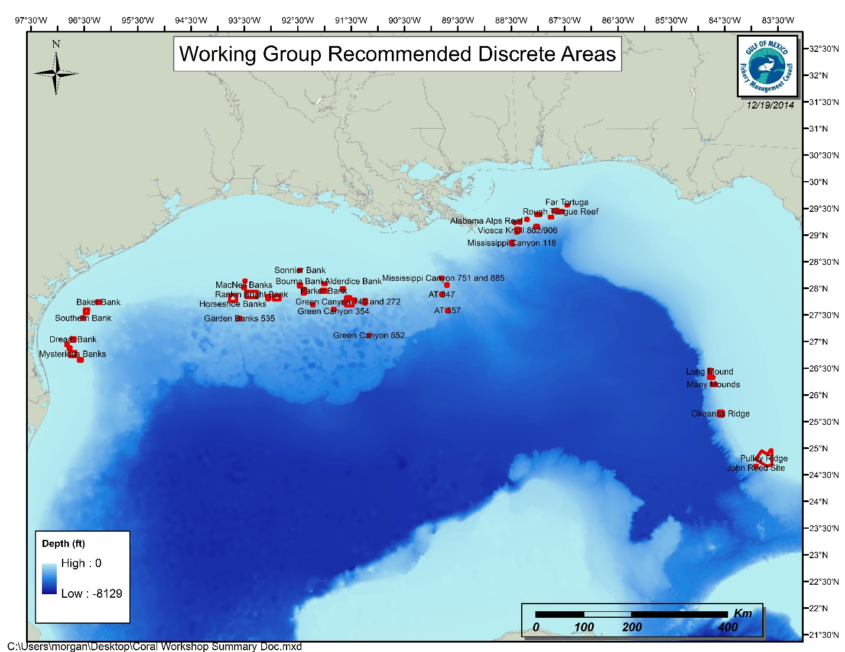

|  |
| --- |
|  |
|  |

Figure 2. Broad overview of the broad coral areas identified by the coral working group. Note: this map does not include HAPCs or other areas with fishing regulations. This map is only the discrete areas that are not currently identified as HAPCs or coral areas, or are identified as HAPCs but have no restrictions.



  
  
  
  
  
  